Person Centred Thinking and Planning

Introducing Person Centred Thinking

For people being supported by services, it is not person centred planning that matters as much as the pervasive presence of person centred thinking. If people who use services are to have positive control over their lives, if they are to have self directed lives within their own communities then those who are around the person, especially those who do the day to day work need to have person centred thinking skills. Only a small percentage of people need to know how to write good person centred plans, but everyone involved needs to have good skills in person centred thinking, in the value based skills that underlie the planning.

There are a number of reasons for this. Teaching and supporting the use of person centred thinking skills will mean that:

It is more likely that plans will be used and acted on, that the lives of people who use services will improve

You will have a number of ways to get plans started

Updating the plans will occur “naturally”, needing less effort and time

Every style of person centred planning is rooted in a person centred way of thinking. It is made up of a set of value-based skills that result in seeing the person differently and give us a way of acting on what is learned. Training in person centred planning is training in a way of thinking as much as it is in a way of developing a plan.

In essential lifestyle planning we have identified 5 basic skills and with 7 tools. One way to think about them is in this skill pyramid:

Supporting Dreams
Supporting Relationships/ Community Connecting

Being ‘Mindful’ and Recording Learning:

- Working/ Not Working
- The 4 Questions
- Learning Log

Matching Staff and Those Using Services
Learning, Using and Recording Communication
Recognizing/ Sorting Important To and Important For: Finding the Balance Between
Defining Staff Roles and Responsibilities

Skills Needed To Support People

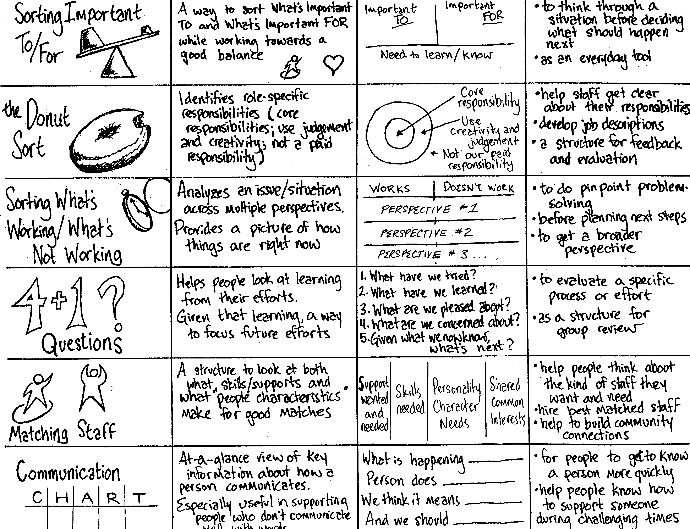

Person Centred Thinking and Planning in Practice

Here is a way of thinking about progress in developing person centred thinking and planning within your organisation.

Is there a process for listening to what people supported and their families want?  Does that lead to action? | What would you see at an  individual/ team level? | What would you see at an organisational level?
People are at the centre of person centred planning and this includes having the opportunity to lead their own plan | Person Centred Thinking  - Staff and managers separating what is important to from what is important for the people they support and finding a balance between them  - Managers and staff defining their roles and responsibilities based on what is important to and for people who they support  - A good match between those who are paid and those who use the services  - Ways to learn, use, and record how people communicate (especially with people who do not communicate with words)  - Examples of how staff and managers reflect on what they are learning about the people they support and the service they provide  - People using relationship circles and other ways of identifying who they want to be part of their planning process  Person Centred Planning  - People using relationship circles and other ways of identifying who they want to be part of their planning process  - People using resources such as ‘Our Plan for Planning’ to work out how they want to stay central to their planning meeting  - Person centred planning meetings happening at various community venues – as chosen by the person  - Person centred planning meetings happening at various times of the day as chosen by the person  - People attending ‘Listen to Me’, ‘Dreaming workshops’ Reach for the Stars’ or similar courses/events to develop their own plans  - People choosing their own facilitator  - People using resources such as ‘Capacity Works’ and ‘Listen to Me’ to gather information for their own plan | People with learning disabilities as part of the implementation group  A policy that reflects the organisations commitment to person centred thinking and planning and to people being are at the centre of planning their lives  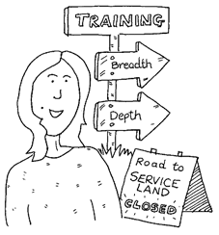  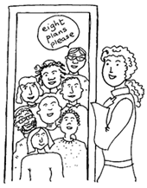
Families and friends are partners in planning processes and action | - Family members and friends attending planning meetings  - Family members and friends working with the person to achieve actions identified at the meeting | Family members and friends as part of the implementation group  A policy that reflects the organisations commitment to family members and friends being partners in planning and action
Staff know what is important to individuals, what support they want and what they want for the future – this is recorded as a person centred plan and action plan | The plan describes the persons capacities, or what people like and admire about them  The plan describes what is important to the person - what matters to them, from their perspective  The plan clearly identifies the supports that the person requires - what is important for them to stay healthy and safe  The plan results in actions that reflect a good balance between what matters to the person (what is important to them) and what is important for the person to stay healthy and safe  The plan identifies what needs to stay the same or be enhanced in the person’s life, and what needs to change (in order that the person has more of what is important to them in their life). Actions are set that identifies what need to change and who will do this by when.  Staff can describe the above  Individuals using their person centred plans used to recruit their own staff | A policy that reflects the importance of person centred plans:  - As a way to record what is important to someone, and for recording ongoing learning  - In recruiting staff  - In supervising and supporting staff  - In evaluating whether the organisation is achieving its outcomes  - In learning about what needs to change and directing service developments  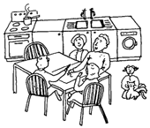
There are clear processes for continually listening to people and recording what is learned  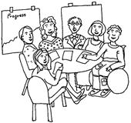 | The people implementing the plan have agreed processes for:  - Ensuring that the plans happens and reviewing actions  - Reflecting on how the team is implementing the plan and learning from what is working and not working  - Recording and sharing what they are continuing to learn about the person (e.g. using Learning Logs)  - Supporting the person to have new opportunities  - Sharing what they are learning with others in the organisation (e.g. senior manager or group responsible for implementing planning) | 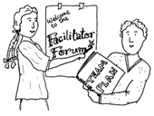
Someone has responsibility for leading person centred planning and approaches within the organisation | 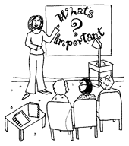 | There is a person centred planning coordinator or someone who is recognised as leading person centred developments  There is a group of people (implementation group) who share responsibility with the above lead person for process for ensuring that staff listen to what people supported and their families want and that this listening leads to action.
There are trained and supported facilitators | Individuals and team members know who to contact if they want a person centred plan | There is a training programme for facilitators that includes more than one planning style (e.g. Paths, Maps, Personal Futures and ELP)  There are clear criteria and expectations for people attending facilitator training  Facilitators are regularly supported in different ways (e.g. attending action learning sets, buddy groups, having mentoring or coaching sessions)
Learning from person centred plans is linked to organisational development | 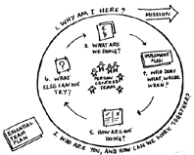 | The learning from facilitators is regularly shared and actioned by the implementation group  The implementation group evaluates what is working/not working from different peoples perspectives (at least annually)  There are processes in place for evaluating the 4 questions of quality described in the guidance:  Are people doing it?  Are they doing it right?  Is it changing people’s lives?  Is it changing our service?
Everyone understands the principles of person centred planning and knows their role at all levels |  | The policy makes it explicit what is expected of different people in different roles around person centred planning  There is training available to enable people to fulfil this – eg training in person centred teams and implementing plans for first line managers, training in individual service design for care managers

Written by Helen Sanderson with graphics by Ruth Mathiesen

For information on the practical two day course that teaches all of the person centred thinking skills, or other courses please contact Helen Sanderson on helen@helensandersonassociates.co.uk or visit our website www.helensandersonassociates.co.uk

Your Notes from the workshop…

WHAT HAVE
I HEARD?

WHAT DOES THIS MEAN
TO ME?

WHAT WILL
I DO NEXT?

